

**HUMAN COMPUTER INTERACTION**

**SSE3306**

**USABILITY TEST REPORT**

**WEBSITE:**

<https://www.nhlbi.nih.gov/health/educational/lose_wt/BMI/bmicalc.htm>l

|  |  |  |
| --- | --- | --- |
| **Group Members** | **Matric Number** | **Role** |
| Muhammad Harith Bin Zainudin | 192171 | Leader |
| Noraein Binti Sabtu | 192661 | Designer |
| Siti Nur Syahirah Bt Mohd Ashri | 193578 | Usability tester |
| Nurhafizah Bt Hasan | 193574 | Programmer |

TABLE OF CONTENTS

**Introduction** **2**

**Executive Summary** **2**

**Methodology** **3**

Sessions 3

Participants 4

Evaluation Tasks/Scenarios 4

**Results** **4**

Task Completion Success Rate 4

Task Completion Rates 5

Task Ratings 5

Ease in Finding Information 5

Keeping Track of Location in Site 6

Predicting Information Section 6

Time on Task 6

Errors 7

Summary of Data 7

Overall Metrics 7

Overall Ratings 7

Likes, Dislikes, Participant Recommendations 9

**Recommendations** **10**

**Prototype** **11**

**SUS for the Prototype** **14**

**Conclusion** **15**

**Attachments and References** **16**

# Introduction

Nhlbi.niv.gov serves as a websites for health purpose. NHLBI stands for National Heart, Lung, and Blood Institute. This website provide global leadership in research, training, and education to prevent and treat heart, lung, blood and sleep disorders. Furthermore, this websites also provide Body Mass Index Calculator (BMI). BMI is a measure of body fat based on height and weight that applies to adult men and women. A usability test is intended for this calculator to determine the extent and interface facilitate a user’s ability to complete routine tasks. This test is conducted with a group of potential users using questionnaire based on System usability scale (SUS). Users are asked to complete a series of routine tasks. Sessions are recorded and analyzed to identify potential areas for improvement to the website.

# Executive Summary

The Nhlbi.niv.gov website were tested by using the questionnaire by the usability tester. Numbers of participants that were involved in the test were 5 peoples(mix of genders and ages). We chose respondents that claimed that they use the internet daily. The usability test used a number of questions in the questionnaire that test the complexity, ease of use of the websites and more. For our test, we present each respondent with several tasks. Each of these "scenario tasks" presented a brief context, then asked the respondent to complete specific task. The team conducted the usability testing at the college on 3rd May 2019. The purpose of this test is to access the usability of the interface design. 5 respondents participated in this test where each individual session lasted approximately 10 minutes. There were 2 tasks scenario that were given to the respondents. In general, all respondents found that the websites clear and straightforward. The test identified only a few minor problems including:

* The lack of organization of information in the pages
* The lack of information on how to change the Standard International Unit (SI unit)
* The lack of giving information after calculating the BMI

This document contains the participant feedback, satisfactions ratings, task completion rates, ease or difficulty of completion ratings, time on task, errors, system usability scale and recommendations for improvements. A copy of the scenarios and questionnaires are included in the Attachments’ section.

# Methodology

## Sessions

The usability tester contacted and recruited students around college. The usability tester sent WhatsApp to students informing them of the test logistics and requesting their availability and participation. Participants responded with an appropriate date and time.

Each individual session lasted approximately 10 minutes. During the session, the usability tester explained the test session and asked participants to read the task scenarios and tried to do it on the website. Then, participants need to execute the task and answer the questionnaire.

After each task, the administrator asked the participant to rate the interface on a

* How easy it was to find the information from the main interface.
* Ability to keep track of their location in the application.
* Accurateness of predicting which section of the application contained the information.

After the last task was completed, the test administrator asked the participant to rate the application overall by using a 5-point Likert scale (Strongly Disagree to Strongly Agree) for ten subjective measures including:

* Would like to use this system frequently.
* Complexity of application.
* Ease of use.
* Learnability.
* User control and freedom.
* Consistency.
* Efficiency of use.
* Flexibility
* Help and documentation
* Visibility of the system.

In addition, the test administrator asked the participants the following overall website questions:

* What the participant liked most.
* What the participant liked least.
* Recommendations for improvement.

See Attachment C for the subjective and overall questionnaires.

## Participants

All participants were the student of Universiti Putra Malaysia who are obsessed with their health. There are a total of 5 participants. 3 of the are women and the rest are men.

|  |  |
| --- | --- |
| **Women** | **Men** |
| 3 | 2 |

## Evaluation Tasks/Scenarios

Participants attempted completion of the following tasks. There are two tasks that participants need to complete.

* Show to us how to calculate the bmi in this website
* Show to us how you view the report after you have calculate the bmi

# 

# Results

## Task Completion Success Rate

All participants successfully completed Task 1 (calculate BMI) and Task 2 (View report after calculating BMI)

### Task Completion Rates

|  |  |  |
| --- | --- | --- |
| **Participant** | **Task 1** | **Task 2** |
| 1 | √ | √ |
| 2 | √ | √ |
| 3 | √ | √ |
| 4 | √ | √ |
| 5 | √ | √ |
| **Success** | 5 | 5 |
| **Completion Rates** | 100% | 100% |

## 

## Task Ratings

After the completion of each task, participants rated the ease or difficult of completing the task for three factors:

* It was easy to find my way to this information from the homepage.
* As I was searching for this information, I was able to keep track of where I was in the website.
* I was able to accurately predict which section of the website contained this information.

The 5-point rating scale ranged from 1 (Strongly disagree) to 5 (Strongly agree). Agree ratings are the agree and strongly agree ratings combined with a mean agreement ratings of > 4.0 considered as the user agrees that the information was easy to find, that they could keep track of their location and predict the section to find the information.

### Ease in Finding Information

All participants agreed it was easy to find how to calculate the BMI when they go to the page (mean agreement rating = 5.0) and 60% found it easy to find the report of their BMI (mean agreement rating = 3.0).

### Keeping Track of Location in Site

All participants found it easy to keep track of their location in the site while calculating the BMI (mean agreement rating = 5.0) and also 80% participant found it easy to keep track of their location while viewing the report of their BMI (mean agreement rating = 4.0).

### Predicting Information Section

All the participants agreed it was easy to predict where to find the button to calculate the BMI (mean agreement rating = 5.0) and all participants agree also where to find the report of the BMI (mean agreement rating = 5.0).

Test 1 - Mean Task Ratings and Percent Agree

|  |  |  |  |  |
| --- | --- | --- | --- | --- |
| **Task** | **Ease - Finding Info** | **Location in site** | **Predict Section** | **Overall** |
| **1 - Calculate BMI** | 5.0 (100%) | 5.0 (100%) | 5.0 (100%) | 5.0 |
| **2 - View BMI Report** | 3.0 (60%) | 4.0 (80%) | 5.0 (100%) | 4.0 |

*\*Percent Agree (%) = Agree & Strongly Agree Response combined*

## 

## Time on Task

The testing software recorded the time on task for each participant. Some tasks were inherently more difficult to complete than others and is reflected by the average time on task.

Task 1 required participants to calculate the BMI and took the longest time to complete (mean = 38 seconds). However, completion times ranged from 25 seconds to 50 seconds with most times less than 40 seconds.

Time on Task

|  |  |  |  |  |  |  |
| --- | --- | --- | --- | --- | --- | --- |
|  | **P1** | **P2** | **P3** | **P4** | **P5** | **Avg. TOT\*** |
| **Task 1** | 50 | 35 | 42 | 25 | 39 | 38.2 |
| **Task 2** | 10 | 5 | 3 | 8 | 4 | 6 |

## Errors

Type of error that the participant make during completing the task is calculating the BMI. All of the participant make this error because of the standard international unit. This website provide the user to fill in their height in feet and inches while the weight in pounds. This confuse all the participants as they use the SI unit in centimeters for height and kilogram in weight.

## Summary of Data

The table below displays a summary of the test data. Low completion rates and satisfaction ratings and high errors and time on tasks are highlighted in red.

Summary of Completion, Errors, Time on Task, Mean Satisfaction

|  |  |  |  |  |
| --- | --- | --- | --- | --- |
| Task | Task Completion | Errors | Time on Task | Satisfaction* |
| 1 | 5 | 5 | 38 | 5.0 |
| 2 | 5 | 0 | 6 | 4.0 |

*Satisfaction = Mean combined rating across three post-task measures: ease of finding the information, ability to keep track of location in site, and site information prediction accuracy.

## Overall Metrics

### Overall Ratings

After task session completion, participants will answer the questionnaire that is based on System Usability Scale (SUS). Below is the question that is in the SUS.

* I think that I would like to use this website frequently
* I found this website unnecessarily complex
* I thought this website was easy to use
* I think that I would need assistance to be able to use this website
* I found the various functions in this website were well integrated
* I thought there was too much inconsistency in this website
* I would imagine that most people would learn to use this website very quickly
* I found this website cumberstone/awkward to use
* I felt very confident using this website
* I needed to learn a lot of things before I could get going with this website.

Comment from every participant regarding the website:

**Participant 1**: The websites is nice, but I cannot seem to find the button to change the unit.

**Participant 2**: Is this the only report that will tell us when we have calculate the BMI? I thought there is more that they have to tell us like what to do and so on.

**Participant 3**: This is useful as it is simple, but maybe try to give info on how to change the SI unit.

**Participant 4**: It is crowded and I do not like the way they align the word. I prefer minimalist.

**Participant 5**: Wow! It is easy, you just need to fill in and then click calculate.

**Post-Task Overall Questionnaire (System Usability Scale)**

|  |  |  |  |  |  |  |
| --- | --- | --- | --- | --- | --- | --- |
|  | **Strongly Disagree** | **Disagree** | **Neutral** | **Agree** | **Strongly Agree** | **SUS Score** |
| I think that I would like to use this website frequently |  | 1 | 3 | 1 |  | 1+6+3=10  10/5 =2 |
| I found this website unnecessarily complex | 1 | 2 | 2 |  |  | 4+6+4=14  14/5=2.8 |
| I thought this website was easy to use |  |  | 1 | 4 |  | 2+12=14  14/5=2.8 |
| I think that I would need assistance to be able to use this website | 1 | 2 | 2 |  |  | 4+6+4=14  14/5=2.8 |
| I found the various functions in this website were well integrated |  | 1 | 3 | 1 |  | 1+6+3=10  10/2=2 |
| I thought there was too much inconsistency in this website |  | 2 | 2 | 1 |  | 6+4+1=11  11/5=2.2 |
| I would imagine that most people would learn to use this website very quickly |  |  | 1 | 2 | 2 | 2+6+8=16  16/5=3.2 |
| I found this website cumberstone/awkward to use | 3 | 2 |  |  |  | 12+6=18  18/5=3.6 |
| I felt very confident using this website |  |  | 3 | 2 |  | 6+6=12  12/5=2.4 |
| I needed to learn a lot of things before I could get going with this website. | 4 | 1 |  |  |  | 16+3=19  19/5=3.8 |
| **TOTAL** |  |  |  |  |  | 2+2.8+2.8+2.8+2+2.2+3.2+3.6+2.4+3.8=27.6  27.6*2.5=**68** |

Based on the table, the result of SUS score is 68. This is NOT a percentage, but it is a clear way of seeing your score. The System Usability Scale is not diagnostic and will not tell what specific problems we face, but it will give us red or green light to know how badly the usability needs work.

If the score is under 68, then there are probably serious problem with the website.

Here’s an overview of how scores should measure:

* 80.3 or higher is an A. People love the site and will recommend it to their friends
* 68 or thereabouts gets a C. The sire are doing OK but could improve
* 51 or under gets a big fat F. Make usability your priority now and fix this fast.

### Likes, Dislikes, Participant Recommendations

Upon completion of the tasks, participants provide feedbacks on what they liked the most and least about the website, and recommendations for improving the website. After we have seen the SUS score, then we know this website need a big change in order that we can improve the SUS score for our new prototype.

**Liked Most**

The following comments capture what the participants liked most:

This calculator is easy to use.

**Liked Least**

The following comments capture what the participants liked the least:

It is hard to complete the task because in our country we only use centimeters for height and kilograms for weight but in the website, you need to convert the SI unit in order to calculate the BMI.

**Recommendations for Improvement**

Use a suitable SI unit for the application in order it is going to be easy for the user to calculate their BMI. There is also not enough information and tips regarding the body weight that we are having. Insert more function that can be calculated such as water intake and more.

# 

# Recommendations

|  |  |  |
| --- | --- | --- |
| **Change** | **Justification** | **Severity** |
| Change and show the standard international unit to the most common use that is kg in weight and cm in height. | This SI Unit is most used in most region compared to pound, feet and inches. We are creating a websites for the user, and the user is using kg and cm. So, it is not necessary for us to show them the pound, feet and inches. Thus, mostly of the user seem frustrated when seeing this pound, feet and inches as they are not used to it. This make them have to convert first and think before typing their weight and height.  Yes, the website provide the metrics for the kg and cm, but it seems, the user does not well aware of that as they are completing task 1. So, it need to be shown properly so that user are well aware. | Medium |
| Making the calculator more minimalist and easy to read | The original calculator in the websites is not align correctly. We can see that the information also is not aligned. User like to see something that is organize. There are some participant like to see that the calculator is designed minimalist. | Low |
| Put more information after calculating the BMI and show the report | As we tell the participant to complete task 2, they seem searching for the report button, but then there is no report button. The information that they provide is limited and only show for the category.  Some of the user want to see the full summary of the BMI. What they have to do after they have calculate the BMI like exercise thrice a week, drink plenty of water, avoid oily food etc | low |

# Prototype

We use high fidelity because we can easily produce a good improved design based on this prototype.

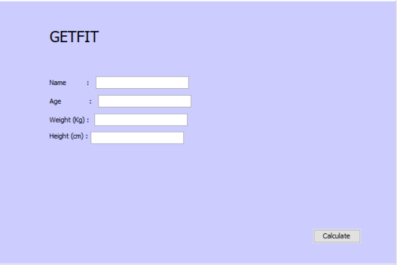

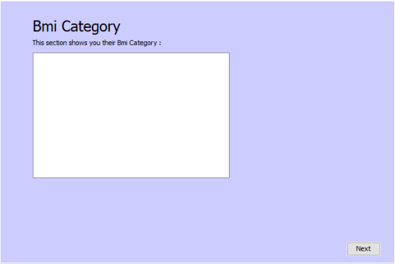

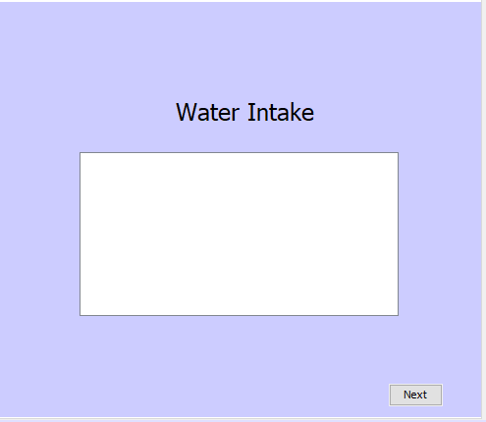

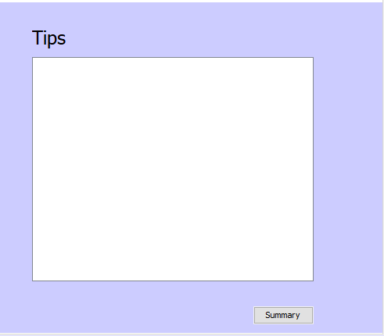

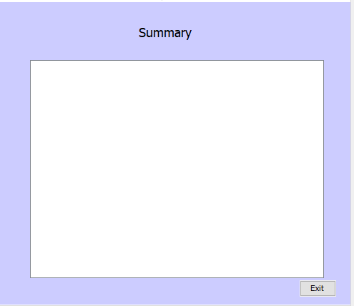

# 

# Application

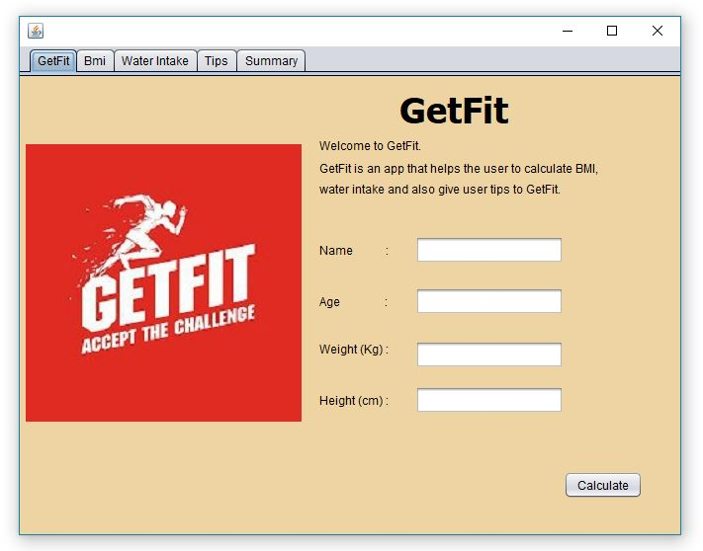

Main page for the application where the user need to insert their details to enable the application to calculate the users’ BMI.

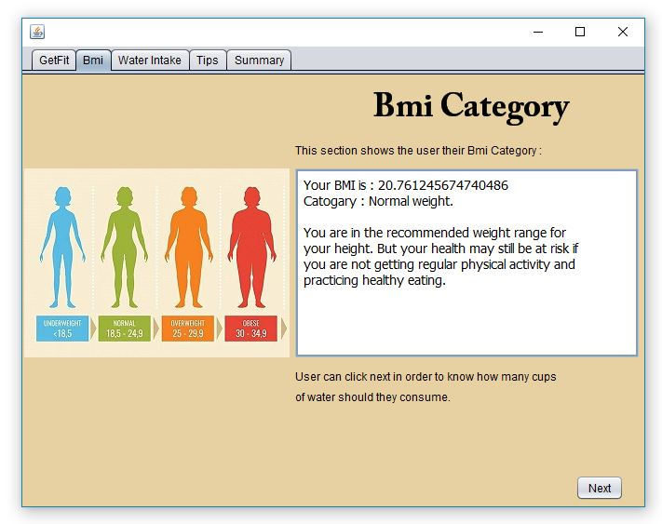

BMI category of the user were showed after the user has inserted their data in the main page which includes the users’ weight category.

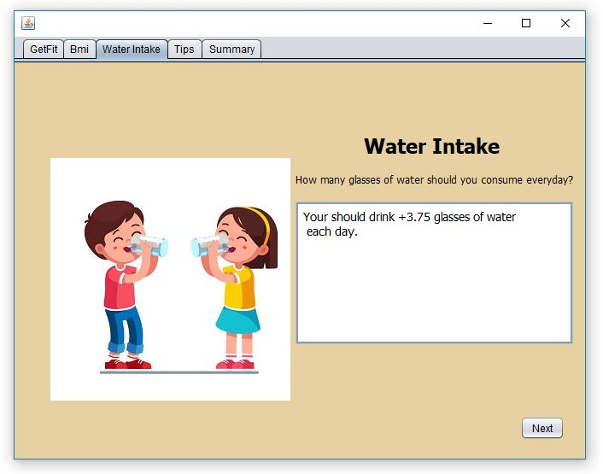

The water intake interface enable users to check how many cups of water should they drink everyday.

# 

User will then proceed to the next interface which is the tips interface where the user will be given tips for the users’ body type in order for them to stay healthy.

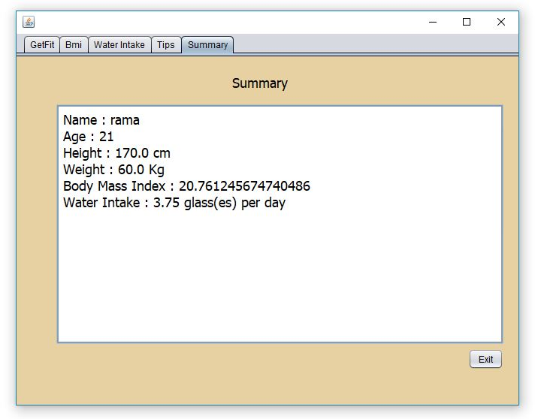

Lastly, once the user have completed every task, the summary report that includes the users’ name, age, height, weight, bmi and water intake were summarise at the summary interface.

# SUS for the Prototype

**Post-Task Overall Questionnaire for the prototype (System Usability Scale)**

|  |  |  |  |  |  |  |
| --- | --- | --- | --- | --- | --- | --- |
|  | **Strongly Disagree** | **Disagree** | **Neutral** | **Agree** | **Strongly Agree** | **SUS Score** |
| I think that I would like to use this application frequently |  |  |  | 1 | 4 | 3+16=19  19/5 =3.8 |
| I found this application unnecessarily complex | 1 | 4 |  |  |  | 4+12=16  16/5=3.2 |
| I thought this application was easy to use |  |  |  | 2 | 3 | 6+12=18  18/5=3.6 |
| I think that I would need assistance to be able to use this application | 3 | 2 |  |  |  | 12+6=18  18/5=3.6 |
| I found the various functions in this application were well integrated |  |  |  | 3 | 2 | 9+6=15  15/5=3 |
| I thought there was too much inconsistency in this application | 2 | 2 | 1 |  |  | 8+6+2=16  16/5=3.2 |
| I would imagine that most people would learn to use this application very quickly |  |  |  |  | 5 | 2o  20/5 = 4 |
| I found this application cumberstone/awkward to use | 3 | 2 |  |  |  | 12+6=18  18/5=3.6 |
| I felt very confident using this application. |  |  |  | 2 | 3 | 6+12=18  18/5=3.6 |
| I needed to learn a lot of things before I could get going with this application | 4 | 1 |  |  |  | 16+3=19  19/5=3.8 |
| **TOTAL** |  |  |  |  |  | 3.8+3.2+3.6+3.6+3+3.2+4+3.6+3.6+3.8=35.4  35.4*2.5=**88.5** |

Based on the table, the latest result of SUS score is 88.5. If we compare with the website SUS, it is 69. There is a huge difference!

# Conclusion

Most of the participants found this website is not complicated, well integrated, very consistency and ease to use. The navigation and information inside the application is very organised so user does not have any trouble while using this application. It is also shows that most of the people would learn to use this application very quickly. To conclude, most of the users is very satisfied with the website. But, we make a little improvement so that the interface is more interesting and will not make user feel frustrated and unsatisfied. The website is usable, but a little change in the interface will surely make big difference.

# Attachments

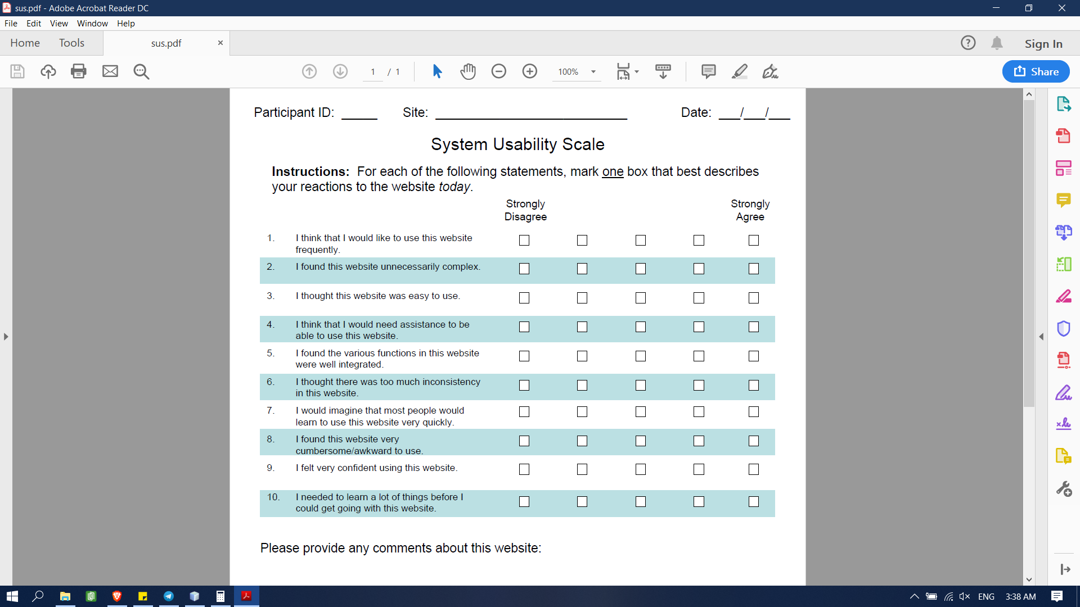

Attachment - Post-Task Questionnaire

Project Logbook

Group name : BlackPink

Title : GetFit

|  |  |  |  |  |
| --- | --- | --- | --- | --- |
| No. | Activity | Date meeting with Dr. Azrina | Comment(s) | Action taken |
| 1. | Usability Test Plan | 23/3/2019 | -The objectives of the Test Plan were not specific and it is too general.  -The objective that we want to achieve should be placed at each stage so we know what are we supposed to achieve.  -Conclusion should be made after each test were conducted so we know whether we achieve the objectives of the test plan or not.  -We need to evaluate again once each stage in the test plan were completed.  -Every testing that were conducted should be in detailed. | - The objectives of our test plan were modified to be more specific.  - Objectives were placed at each of the stage.  -Conclusions were made after we have conducted each test.  -Evaluation were conducted after we were done with each stage.  -Testing were conducted in a detailed manner. |
| 2. | Questionnaire | 25/4/2019 | - We need to find how to calculate the task completion rate of the questionnaire.  - If the user comment on the spot, then we need to record the comment then we need to interpret what the user wants.  - If all or most of the participants give the same comment, then we classify it as cathostrophic. | -We managed to find the way to calculate the task completion rate percentage.  - Users comment were recorded and we build the application based on the interpretation from the users’ comments. |

References

1. <https://measuringu.com/sus/>
2. <https://www.usability.gov/how-to-and-tools/methods/system-usability-scale.html>
3. /<http://uxpajournal.org/wp-content/uploads/pdf/JUS_Bangor_May2009.pdf>
4. <https://uxplanet.org/how-to-measure-product-usability-with-the-system-usability-scale-sus-score-69f3875b858f>
5. <https://usabilitygeek.com/how-to-use-the-system-usability-scale-sus-to-evaluate-the-usability-of-your-website/>